**Unit 10 You’re supposed to shake hands.**

**教学目标**

话题：礼仪、习俗 (Customs)

功能：谈论不同国家的习俗和你应该做的事(Talk about customs and what you are supposed to do)

A: What are you supposed to do when you meet someone for the first time?

B: You're supposed to shake hands.

A: Am I supposed to wear jeans?

B: No, you're expected to wear a suit and a tie.

A: Is it important to be on time?

B: Yes, it's important to be on time

语法：

1能正确运用 be supposed/expected to+ infinitive结构表示应该或被期望做某事(be supposed to + infinitive; be expected to + infinitive)

A: What are you supposed to do when you meet someone for the first time?

B: You're supposed to shake hands. You're not supposed to kiss.

When were you supposed to arrive?

Am I expected to wear jeans?

2能正确使用 It is *adj*. to do sth.结构 (It is + *adj*.+ infinitive)

Is it impolite to keep others waiting?

s important to be on time.

词汇和常用表达：

1. 能正确使用下列词汇 (Curriculum words)

capital, noon, passport, chalk, blackboard, coast, season. manner,

exchange, granddaughter, suggestion, kiss, greet, value, knock,

behave, relaxed, mad, northern, eastern, worth, empty, basic, except

1. 能正确使用下列常用表达 (Useful expressions)

drop by, after all, get mad, make an effort, clean .. off, take off, go out of one’s way, make... feel at home, get used to

1. 能认读下列词汇 (Non-curriculum words)

custom, bow, effort, teenage, elbow, gradually

学习策略: 能借助记笔记或要点归纳的方式加强语言记忆,使短时记忆转化为长期记忆。

文化知识：了解各国文化背景、礼仪习俗,学会在不同场合的得体表现,提升跨文化意识。

**Section A 1 (1a-2d)**

**一、教学目标：**

1. 能掌握以下单词： custom, bow, kiss, greet, be supposed to

掌握be supposed to句型的用法。

2. 学习一些见面礼仪，生活习俗和对时间的看法。

3. 了解西方国家的风土人情和习俗。

二、**教学重难点**

1. 教学重点：be supposed to的用法

2. 教学难点：中西方人们见面礼仪的差别。

培养学生跨文化交际意识。

**三、教学过程**

**I. Warming up**

师生讨论： 学生在学校应该做哪些事情？引出新句型。

如 ：Is it right to come to class late?

S: No.

T: That’s right. It’s not a good idea to come late. You’re not supposed to come to class late. You’re supposed to …

eat in class, do homework every day, raise your hand before talking等做更多的练习，引出be supposed to句型

**II. Discussion**

T: How do people greet one another in countries around the world?

Work in pairs and discuss the question.

S: …

利用多媒体播放各种见面的礼仪，学习新单词：custom, bow, kiss, greet

**III. Work on 1a-1c**

1. Work on 1a

多媒体呈现1a图片，让学生根据图画内容，说说图中的握手，接吻，鞠躬是哪个国家的礼仪，然后按要求把书本给出的“国家”和“习俗”连接起来。

2. Listening 1b.

Listen to the recording and check your answers to activities in 1a.

3. Listen again and fill in the blanks.

Yoshi: What are people _________ to do when they meet in your country, Rodrigo?

Rodrigo: Do you mean when people meet for the first time?

Yoshi: Yeah.

Rodrigo: In Mexico, we ___________.

Yoshi: What about in Brazil, Celia?

Celia: Well, in Brazil, people sometimes ____. How about in Japan, Yoshi? What are people expected to do when they meet for the first time?

Yoshi: We _______.

Kim: And in Korea we also bow.

Mike: Well, I guess in most Western countries we _____________.

4. Pair work**:**

A: What are people in Korea/… to do when they meet for the first time?

B: They are supposed to bow. How about in the United States?

A: They’re supposed to shake hands.

5. 教师介绍本单元的目标语言：You’re supposed to ….

**Ⅳ. Listening**

1. Listen to 2a. What mistakes did Maria make?

2. Finish 2a.

3. Listen to 2b and fill in the blanks.

1) Maria was supposed to arrive at 7:00, but she _____________.

2) In Maria’s country, when you’re invited for 7:00, you’re expected to ___________.

3) When Maria met Paul’s mom, she was supposed to ___________.

4) Maria should ask what she is supposed to _____ if she is invited to a party

next time.

4.Pair work

Read the listening text and act out the dialogue.

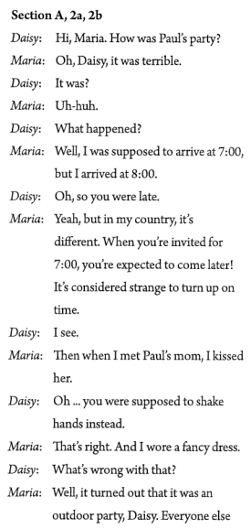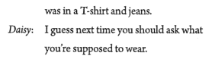

**V. Role play**

Work on 2d

Role-play the conversation between Katie and John.

Read the conversation again and answer these questions:

1. What does John think of the welcome party?

2. What did John do when he met Sato?

3. Did John return the bow in the end?

4. What did Katie do when she first met Marie last year?

5. What are French people supposed to do when they see each other?

Fill in the blanks according to the conversation.

The welcome party for foreign students last night was great. And John found a funny thing: different countries have different customs. People ________________ do differently when they meet for the first time. In Japan, people _______________ bow when they meet. In France, people ______________ kiss when they see each other. When in Rome, do as the Romans do.

**VI. Consolidation**

When in Rome, do as the Romans do.

让学生展示上课前通过网络或书籍等形式查找到的各国礼仪， 并分类记录， 制成表格。

**VII. Language points**

进一步向学生讲解本单元的目标语言: be supposed to, be expected to.

1. You are supposed to shake hands.

be supposed to do… “应该……被期望做……”，当句子的主语是人时，它可

以用来表示；劝告，建议，义务，责任等，意思是to be expected to do sth., or to have to do sth.

e.g. You’re supposed to ask the teacher if you want to leave the classroom.  
 如果你要离开教室，应该先问问老师。  
 We are not to supposed to play football on Sunday.

不准我们在星期日踢足球。

2. That’s how people in Japan are expected to greet each other.

greet =to welcome or say “hello” 动词 “问候，打招呼”

e.g. He greeted her by saying “good morning”.

他向她打招呼说 “早上好”。  
 She greeted me with a friendly smile. 她向我微笑致意。

be expected to 有望做某事；被期待做

e.g. John is expected to come to the party tonight.

约翰应该会出席今晚的宴会。

3. I held out my hand and to my surprise, she kissed me on both sides of my face!

to one’s surprise 令某人惊讶的是

e.g. To my surprise, they said okay. 令我惊讶的是，他们说可以。

kiss sb. on…= give sb. a kiss on…亲吻某人的……

e.g. She kissed the child on the forehead.

=She gave the child a kiss on the forehead.

她吻了孩子的额头。

**VIII. Exercises**

Ⅰ. 根据句意，从方框中选择恰当的单词填空，有的需要变换形式。

custom, bow, side, greet, kiss

1. People in Japan like to _________ to each other when they meet.

2. Before going to bed, Mom often _________ me and says “Good night” to me.

3. Different countries have different _________. We should learn something

about them.

4. Carla _________ me with “hello”, and I gave her a sweet smile in return (作为回报).

5. There are many beautiful flowers on both _________ of the river.

Ⅱ. 根据汉语意思完成英语句子，每空一词(含缩略形式)。

1. 海斯先生将被期待在会上发言。

Mr. Hayes will __ ________ __ ______ at the meeting.

2. 那就是马库斯与朋友们相处的方式。

______ ____ Marcus gets on with his friends.

3. 令每一个人惊讶的是，这个计划竟然成功了。

___ __________ _________, the plan succeeded.

4. 在阅览室我们不应该大声说话。

We _____ ________ __ talk loudly in the reading room.

5. 我哥哥一毕业就会找工作。

My brother will look for a job __ ____ __ he leaves school.

6. 凯文没有去参加欢迎派对，那晚他觉得不舒服。

Kevin didn’t go to the ________ _____. He wasn’t feeling well that night.

7. 那个小男孩伸出双手，开心地接过他的生日礼物。

The little boy ____ ____ his hands and got his birthday gift happily.

8. 上个月公司新来的那个年轻人犯了一些错误。

The young man who entered our company last month has _____ ____ _________.

**Ⅸ. Homework**

1. Write a passage about different customs in different countries.

2. Preview 3a-3c on page 75.

**Section A 2 (3a-3c)**

一、**教学目标：**

1. 学习掌握下列词汇： relaxed, value, capital, noon, mad, effort, drop by, after all, get mad, make an effort

复习 be supposed to句型。

如何正确的阅读课文。

2. 通过“应该” 与“不应该”进一步了解一些国家的礼仪和对时间的看法。

了解不同国家的不同的时间观念， 加强对中国文化的理解。

二、**教学重难点**

1. 教学重点：

1) 掌握本部分出现的生词和词组，达到熟练运用的目标。

2) 阅读短文，获得相关的信息。通过阅读练习，来提高阅读能力。

2. 教学难点：

1) 阅读短文，获得相关的信息的能力。

2) 理解并运用所学的词汇及表达方式。

**三、教学过程**

**Ⅰ. Revision**

Different countries have different customs.

e.g. A: What are people supposed to do when they meet in...?

B: They are supposed to bow / kiss / shake hands....

**Ⅱ. Warming up**

Are you supposed to be on time when you meet your friends?

Are you supposed to call your friends before you go to their house for dinner?

Are you supposed to make plans to meet your friends?

But people in other countries may have different opinions. Let’s take two of them as examples.

**Ⅲ.Lead-in**

1. 展示哥伦比亚和瑞士照片。使学生熟悉这两个国家的情况， 通过图片欣赏引出本节内容。

2. Look at the pictures and say something about the two countries.

What do you know about Switzerland?

What do you know about Colombia?

**Ⅳ. Reading**

**Fast reading**

1. Work on 3a: Tell Ss to read the article and answer the question:

*In which country is it OK to be 15 minutes late for dinner?*

Ss read the article quickly and try to find the answer to the question.

2. 方法指导：

首先，对原文材料迅速浏览，掌握全文的主旨大意。全文，抓住中心主旨很有必要，在速读的过程中，应尽可能多地捕获信息材料。其次，带着问题，再回到原文中去寻找、捕获有关信息。做好这类题的要领是：1）.明确题意，顺藤摸瓜。2）.按照要求，寻找答案来源。3）.找准关键词，明白其暗示作用。4）再读课文，看答案是否符合题意。

3. 按指导的方法带着问题进行阅读。

4. 最后，教师让部分学生说出自己的答案，并校对答案。

Key: In Colombia.

**Careful Reading**

Work on 3b. Read the passage again and fill in the chart.

|  |  |  |
| --- | --- | --- |
| Ideas and customs about… | Colombia | Switzerland |
| Being on time | it’s OK to be late | it’s important to be on time |
| Visiting a friend’s house | drop in  whenever they like | always call first |
| Making plans with friends | don’t usually make plans | always make plans |

Read 3a again and decide whether the statements are true (T) or false (F).

( ) 1. In Colombia, it’s OK if you arrive a bit late for a dinner.

( ) 2. People in Colombia usually make plans to meet their friends.

( ) 3. In Switzerland, people are pretty relaxed about time.

( ) 4. In Switzerland, people never visit a friend’s house without calling first.

**Post reading**

1. Role-play a conversation between Teresa and Marc. Teresa is late and Marc is mad.

注意使用目标语言： In …, you’re supposed to…

A: Hi, Marc. Sorry, I’m a little late.

B: Teresa, you’re 10 minutes late!

A: It’s just 10 minutes! It’s no big deal!

B: Well, in Switzerland, you’re supposed to…

2. Fill in the blanks.

In Colombia, people are pretty ____________ time. They don’t like to ______________. They often just ________ their friends’ homes. They don’t usually have to ___________ to meet their friends. Often they just walk around the town center, seeing as many of their friends _____ they can.

In Switzerland, it’s very important to be _________. They’re the capital of clocks and watches, _______. They never visit a friend’s house without ___________. They usually make plans to see friends. They usually __________ something interesting, or go somewhere together.

**Ⅴ. Language points**

1. Where I’m from, we are pretty relaxed about time.

在我们那个地方，我们的时间观念比较随意。

where用作连词，引导地点状语从句，说明主句行为发生的地点。

e.g. Remember to keep the kids where you can see them.

记住让孩子们待在你能看得见的地方。

relaxed *adj.* 放松的，自在的

be relaxed about … 对……感到放松

e.g. 不要害怕，轻松面试。

Don’t be afraid, ______________________________.

**just be relaxed about the interview**

2. We value the time we spend with our family and friends in our everyday lives.

value *v.* 珍视，重视

e.g. I’ve always valued my teachers’ advice.

我一直很重视老师们所给的建议。

life *n.* 生活（可数名词）

e.g. Many people make different kinds of friends in their social lives.

许多人在他们的社交生活中结交了各种不同的朋友。

一些常用短语和表达，如live/ have/ lead a …life，如:

She just wanted to live a quiet life.

她只想过平静的生活。

3. We often just drop by our friends’ homes.

drop by 顺便拜访，后面常接表示地点的名词。

e.g. Drop by my home this evening . 今晚到我家来谈谈。

drop in也可表示“顺便拜访”，如果后接人时，用介词on。

e.g. I just drop in on him for a chat.

我只是顺便来和他聊聊天。

4. In Switzerland, it’s very important to be on time.

该句中使用了句型“It’s + *adj.*+ to do sth.”，意为“做某事是……的”。it在句中作形式主语，真正的主语是后面的动词不定式短语to do sth.。如：

It’s necessary to eat healthy food.

【运用】汉译英

住在这样一个现代化的城市里很舒适。

It’s comfortable to live in such a modern city.

5. We’re the capital of clocks and watches, after all!

after all 毕竟

e.g. So you see, I was right after all. 你看, 毕竟还是我对吧。

You decided to come after all. 你毕竟还是决定来了。

6. So I make an effort to be on time when I meet my friends.

make an effort 做出努力

e.g. I will make an effort to stop smoking. 我要尽力戒烟。

You should make an effort to improve your reading ability.

你应该努力提高你的阅读能力.

7. Also, we never visit a friend’s house without calling first.

双重否定句。never和without都表示否定，合在一起表达肯定意义。

e.g. You will hardly ever be able to speak good English without practicing.

你不练习几乎是不可能把英语学好的。

**Ⅵ. Exercises**

根据短文内容及提示用be supposed to do sth.结构补全短文。

How much do you know about table manners around the world? In the United States, (1) _____________________________(你不应该用手拿东西吃). In Japan, (2)__________________________________(走路时你不应该吃或喝东西), and (3)_____________________________________(吃面条时你应该发出声音). It shows that you like the food. In South Korea, (4)___________________(即使是最小的孩子也不能先开始吃饭). In China, (5) ______________________(你不应该把筷子插到食物里). Instead, lay them on your bowl or plate. And sometimes Chinese hosts use their chopsticks to put food into your bowl or plate. This is a sign of kindness.

**Ⅶ. Homework**

Write a short passage to introduce manners about time in China.

**Section A 3 (Grammar Focus-4c)**

一、**教学目标：**

1. 学习掌握词汇：passport, clean…off, chalk, blackboard, northern, coast, season, knock, eastern, take off, worth, manner

进行一步复习巩固学习Section A 部分所学的词组。

掌握be supposed to, be expected to, It is important to do sth的句型。

2. 进一步了解不同国家的风土人情，体会文化礼仪差异，了解中国的基本礼仪。

二、**教学重难点**

1. 教学重点：

1) 复习巩固Section A 部分所学的生词和词组，达到熟练运用的目标。

2) 总结 be supposed to, be expected to, It is important to do sth的不同句型。

2. 教学难点

be supposed to, be expected to, It is important to do sth 的不同句型

**三、教学过程**

**Ⅰ. Revision**

根据汉语提示完成句子。

1. Walking on the beach makes you feel ________ (放松的).

2. Beijing is the _________ (首都）of China.

3. We usually have lunch at ______（中午）.

4. If you _____ _____ _____ _____ (不努力）to study, you won’t pass the English

exam.

5. You should be easy on these students. ____ ____ (毕竟）, they are kids.

6. The Chinese people are great people and _____（重视）customs and traditions above almost everything.

7. Just remember – you can’t ___ ___ (发火）at what they tell you.

What are you supposed to do when you…

see rubbish everywhere? go across the road? see an old man fall down?

We’re supposed to…

**Ⅱ. Grammar Focus.**

1. 学生阅读Grammar Focus中的句子，然后做填空练习。

1) 你第一次遇到某一个人应该做什么？

________ ______ you ______ ______ ______ when you meet someone for the first time?

2) 你应该握手。

You _______ _______ ________ ________ _________.

你不应该亲吻。

_______________________________________.

3) --你应该什么时候到？

--我应当7点钟到。

--When were you ________ _______ _________?

--I _______ ________ ______ _______ at 7:00.

4) --我应该穿牛仔裤吗？

--不应该穿，希望你穿西服打领带。

--__________ I ________ _________ wear jeans?

--No, you _______ ________ _______ wear a suit and tie.

5) --让别人一直等不礼貌吗？

--对，让别人一直等不礼貌。

--_________ ________ ________ to keep others waiting?

--Yes, it’s _______ _________ _______ others waiting.

6) --准时很重要吗？

--是的，准时是很重要。

--Is _______ ________ ______ _______ on time?

-- Yes, it’s important to be on time.

2. 学生们完成填空试题后，可以打开课本检查答案，对错误的句子，单独进行强化记忆。

**Ⅲ. Grammar**

1. ★ be supposed to表示按照规则、规律、义务或约定“应当；理应”去做某事，其中to为动词不定式符号，后接动词原形。如：

You’re supposed to return the bike tomorrow.

★ be supposed to的语意相当于should。如：

You’re supposed to study harder. = You should study harder.

★ be supposed to的否定式是在be后加not，即be not supposed to，其一般疑问句是把be提至主语前。如：

You are not supposed to talk loudly in the hospital.

Am I supposed to get up at 7 o’clock?

★ was / were supposed to常用来把本应该发生的事与实际发生的事进行对照，可译为“本应该”。如：

They were supposed to arrive at nine, but they were late.

2. be expected to do sth.

被期许(预期)会做某事, 被要求做某事，希望做某事, 表示可能性。

e.g. 希望她能在晚餐前到达。

She was expected to arrive before dinner.

be supposed to do相对于be expected to do主观性更强。

【语境应用】根据汉语意思完成英语句子，每空词数不限。

1) 我们应该多读书。

We ______________________________ more books.

2) 你不应该把你的自行车放在这里。

You _________________________________ your bike here.

3) 我本应该今天上午寄信的，但我忘了。

I ____________________ the letter this morning, but I forgot it.

4) 杰克被要求每天早上练习英语。

Jack _____________________ English every morning.

Answers: are supposed to read / should read

aren’t supposed to put / shouldn’t put

was supposed to post

is expected to practice

3. It’s+ *adj.* + to do sth.

不定式做主语时，常用代词it来代替不定式结构。it为形式主语，而不定式作为真正主语被后置。

Practice

1) 读书是有用的。

2) 每天跑步是健康的。

3) 迟到是糟糕的。

It is useful to read.

It is healthy to run every day.

It is bad to be late for school.

It is *adj*. for sb. to do sth. for sb.的句型常用于表示事物的特征

e.g. It is difficult for him to finish the task within two hours.

It is *adj* of sb. to do sth. of sb.的句型常用表示人物的性格，品德

e.g. It is kind of you to help me.

Practice

1. It was stupid ____ me to talk in that way to my mother.

2. It is very important ___ us to master English.

3. It was impossible ____the little boy to carry such a heavy box.

4. It is smart ___ them to make good use of the Internet.

**IV. Consolidation**

Work on 4a.

1.让学生读句子，学习新词，了解句意，选择合适的短语填空。

2. Check the answers with the Ss.

Language point

take off

★ take off可意为“脱下(衣服)”，与put on意思相反。如：

It’s hot in the room. Please take off your coat.

★ take off还可意为“(飞机等)起飞”，与land意思相反。如：

The plane will take off in an hour.

【语境应用】单项选择

(1) The boy likes planes very much and he often goes to see planes land and

___________.

A. take care of B. take off C. take after D. take down

(2) In many eastern European countries, you are supposed to ___________

your gloves before shaking hands.

A. take off B. shut off C. cut off D. put off

Work on 4b.

1. 让学生通读短文, 学习新词，理解大意。

2. 方法指导： 根据我们所学的短语：be supposed to do sth. / be expected to do sth./ It is important (adj.) to do sth. 再结合题目，用适当的形式尝试填空。

3. 找部分学生到黑板, 写出自己填写的答案。

4. 共同检查, 核对答案。

Language point:

worth *adj.* 值（多少钱）; 相当于……的价值

e.g. This old computer is worth 300 dollars.

worth *adj.* ，还可意为“值得”，后接名词(短语)、代词或动词-ing形式，其中动词-ing形式是主动形式表示被动意义。另外，worth常用well修饰，表示“很值得”。

e.g. Is it worth all the trouble?

The new car cost a lot of money, but it’s certainly worth it.

The book is well worth reading.

【语境应用】根据汉语意思完成英语句子，每空一词。

那个地方值得参观。

(1) The place is worth ________.

(2) The place is worth __ _____.

Answers: visiting, a visit

Group work.

Work on 4c.

Learn new word: manner

Make a list of advice for someone coming to your country as an exchange student for the first time. Work with your group to give advice about:

|  |  |
| --- | --- |
| time | what to do for someone’s birthday |
| meeting people | visiting someone’s home |
| table manners | giving gifts |

**V. Exercises**

Ⅰ. 根据语境及所给首字母提示，补全所缺单词。

1. Of the four s              , spring is my favorite.

2. One of the things that Jerry v               is the love of friends.

3. —I k               on the door but nobody answered.

—Oh, we were all out.

4. Don't forget to take your p               with you when you go abroad.

5. As the c               of China, Beijing is a modern city with a long history.

6. Paula likes traveling. It is very interesting and it makes her feel happy and r              .

Ⅱ. 根据句意及所给汉语提示，完成下列句子，每空一词。

1. They often _________ _________(顺便拜访) their friends' homes.

2. Alfred is getting hot, so he is going to _________ _________(脱下) his coat.

3. Although Emily did something wrong, _________ _________ _________ _________ _________(这没什么大不了的).

4. Students should _________ _________ _________ _________(把粉笔从……上擦掉) the blackboard after class.

5. Mr. Griffin _________ _________(大动肝火) because his daughter told a lie yesterday.

6. Brian has lots of work to finish before Friday, so he doesn't even have a rest _________ _________(在中午).

Ⅲ. 根据汉语意思及括号内所给英文提示语，将下列句子翻译成英语。

1. 遵守交通规则是很重要的。 (it)

____________________________________________

2. 艾伦(Alan)计划熬夜吗？ (plan)

____________________________________________

3. 你为什么如此担忧？毕竟不是你的问题。 (after all)

____________________________________________

4. 老师应该鼓励学生们努力学习。 (make an effort)

____________________________________________

5. 布莱克(Black)先生认为中国民族音乐很值得一听。(worth)

____________________________________________

6. 暑假里妈妈让我一直学数学，因为我数学考试不及格。(keep)

____________________________________________

**VI. Homework**

1. Make 5 sentences with *be supposed to do…*

2. 根据小组对4c讨论的结果，写一篇短文。

**Section B 1 (1a-1d )**

一、**教学目标：**

1. 能掌握以下重难点句子：

You’re supposed to …

You’re not supposed to…

It’s impolite to …

You shouldn’t …

提高学生的听力水平。

2. 通过对一些国家的风俗习惯和饮食文化。餐桌礼仪的了解，进一步提高学生对文明生活的认识。

通过学习了解各国的基本礼仪。

培养学生良好的合作能力和良好的行为习惯。

二、**教学重难点**

1. 教学重点：

1) 掌握本课时出现的生词及用法。

2) 进行听力训练，提高综合听说能力。

2. 教学难点

1. 运用所学内容谈论餐桌礼仪。

2. 在听的过程中获取有用的信息。

**三、教学过程**

**Ⅰ. Warming up**

利用大屏幕展示一些国家吃饭的情景，或一些在餐馆吃饭的图片，边放边介绍， 让学生对中西方就餐文化有所了解， 并引入新课。

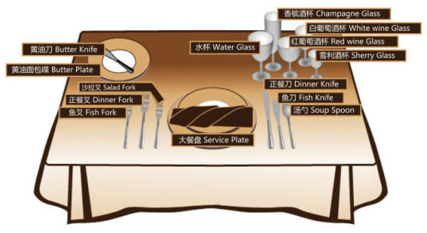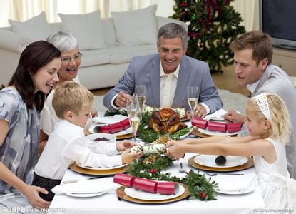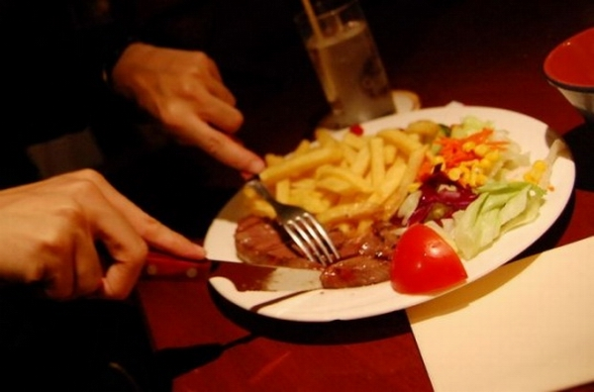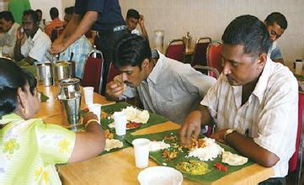

**Ⅱ. A quiz**

1. Work on 1a. How much do you know about table manners around the world? Take the following quiz. Circle T for true or F for false after each sentence.

Mind your manners!

1) In India, you’re supposed to eat with your hands. T F

2) In China, you’re not supposed to stick your chopsticks into the food. T F

3) In Korea, the youngest person is expected to start eating first. T F

4) In France, you’re supposed to put your bread on the table. T F

5) In China, it’s impolite to use your chopsticks to hit an empty bowl. T F

a）先让学生自己做，老师指导，让他们理解每个句子的意思。

b）共同讨论，核对答案。

【拓展】As Chinese, do you know what table manners in China?

We should eat with our chopsticks.

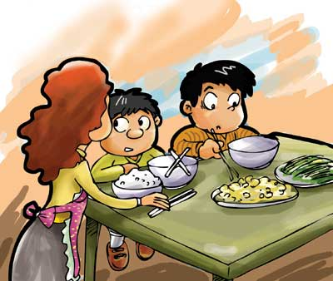

It’s rude to stick the chopsticks into the food.

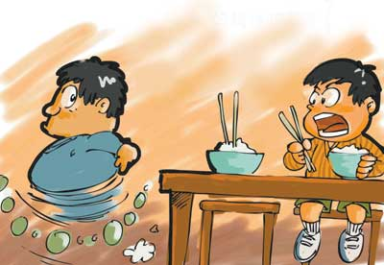

We’re not supposed to talk aloud at the table.

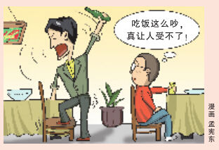

**Ⅲ. Listening**

1) Work on 1b. Steve is going to China to study. His friend Yang Ming is telling him about the table manners in China. Listen and number the pictures in the order you hear them.

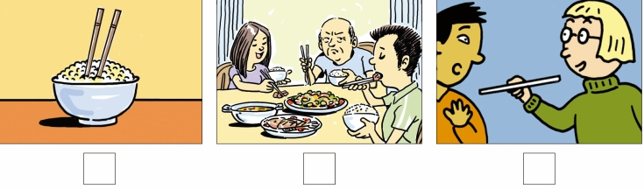

2) Work on 1c. Listen again. Match the sentence parts.

|  |  |
| --- | --- |
| ____ 1. You’re not supposed to…  ____ 2. It’s impolite to…  ____ 3. You shouldn’t… | a. stick your chopsticks into your food.  b. point at anyone with your chopsticks.  c. start eating first if there are older people at the table. |

让学生看1b插图。说一说他们在干什么？然后让学生听第一次录音，把插图的顺序写出来。

再让学生第二次听录音，把1c两部分句子连起来。

3) Listen for the third time, then complete the conversation.

Yang Ming: You must be excited about _______________ tomorrow, Steve!

Steve: Yeah, but I’m a little _______, too.

Yang Ming: Why?

Steve: Well, for one thing, I don’t know _____________ very well… and I don’t know how to _______ at the dinner table.

Yang Ming: Oh, I see. Well, one important thing is that you _________________ start eating first if there are ___________ at the table.

Steve: That’s _________. In the United States, it doesn’t matter.

Yang Ming: Yeah, I know. It’s also _______ to stick your chopsticks into your food. You ______________________ with your chopsticks, either.

Steve: Oh, OK.

Yang Ming: Oh, and there’s one more thing you need to know. You’re not supposed to __________________________. Only parents ______________ talk at the dinner table. Children are not allowed to _____.

Steve: Wow! That’s… that’s unusual!

Yang Ming: Haha, I’m just _______!

**Ⅳ. Practice**

1. 让学生齐读1c 句子。

2. 让学生两人一组操练1d.

Talk about other table manners in your country.

A: We are supposed to…

B: Yes, It’s impolite to…

**Ⅴ. Consolidation**

根据听力和同学的讨论，说说我们的餐桌礼仪，学生四人一组开展活动，共同讨论， 把每个观点都记录下来。从而达到反复操练目标语言的目的。

1. You’re not supposed to start eating first if there are older people at the table.

2. You shouldn’t point at anyone with your chopsticks.

3. It’s impolite to stick your chopsticks into your food.

4. It’s impolite to use your chopsticks to hit an empty bowl.

5. You are not supposed to talk when you’re eating dinner.

6. It’s not necessary to order too many dishes.

7. It’s impolite to make a big noise when you are eating soup.

8. You’re not supposed to put your clothes into a bowl or plate when picking up your food with chopsticks.

**Ⅵ. Explanation**

Mind your manners!

mind…是一个警示句型，“注意……; 当心；小心……”。

e.g. Mind your head, please.

请注意你的头。

*v.* “介意”，常用于否定句和疑问句，后接名词(短语)、代词、动词-ing形式或从句。

单项选择。

1) I don’t _______ the heat, for I’m used to hot weather.

A. like          B. mind           C. know         D. stand

2) I wouldn’t mind _____ a roommate. We can help each other and save money as well.

A. having         B. to have          C. have               D. had

manners“礼貌；规矩；礼节；礼仪”，此时，manner通常用复数形式。

e.g. 满嘴食物说话是不礼貌的行为。

It’s bad manners to talk with your mouth full.

**Ⅶ. Homework**

1. Find the differences about the table manners between France and China

on the Internet.

2. Preview the new words and expressions we will learn in next lesson.

**Section B 2 (2a-2e)**

一、**教学目标：**

1. 能掌握以下单词：basic, exchange, go out of one’s way, make …feel at home, teenage, granddaughter, behave, except, elbow, gradually, get used to

培养阅读能力，理解关键词和短语的能力。

2. 通过对一些国家的风俗习惯和饮食文化。餐桌礼仪的了解，进一步提高学生对文明生活的认识。

通过学习了解各国的基本礼仪。

培养学生良好的合作能力和良好的行为习惯。

二、**教学重难点**

1. 教学重点：

阅读短文，获得相关信息，提高学生们的综合阅读能力。

2. 教学难点

运用所学内容谈论餐桌礼仪。

**三、教学过程**

**Ⅰ. Group work.**

Work on 2a. What do you know about customs in foreign countries? What do you think is the biggest challenge when visiting a foreign country?

*e.g. My cousin went to America, and she said that learning basic table manners was her biggest challenge. She never knew what she was supposed to do at the dinner table.*

提前预习或查阅资料，了解外国的一些餐桌礼仪，你认为到外国参观时最大的挑战是什么？

让学生分享他们的答案。

**Ⅱ. Reading**

播放一个法国人就餐的图片，让学生观察法国人就餐的习惯，然后老师问，他们可以用手拿水果吃吗？设置悬念，引导学生阅读。

**Fast Reading**

1. What is the topic sentence for each paragraph?

2. Read the letter and answer the questions.

1) Why is Lin Yue in France?

2) Does she enjoy staying with her host family? How do you know?

3) How does she feel about making mistakes when she speaks French?

4) What is the biggest challenge she is facing?

Answers: 1. She is a student exchange program.

2. Yes, she does. This can be seen in the way she talks about her host family: that they are nice and they go out of their way to make her feel at home; that the grandmother make Chinese food for her; that the granddaughter is kind and talks to her in French to give her practice.

3. It doesn’t worry her as it used to.

4. Her biggest challenge is how to behave at the dinner table.

**Careful reading**

阅读文章第一段，完成下面的短文，每空一词。

Lin Yue went to France for a student exchange program. Before she arrived there, she was a bit nervous, but in fact things went well with her. Her (1) ____ _____ tried very hard to make her feel at home. The grandmother learned to make (2) _______ _____ for her. The kind granddaughter always helped her practice French. Now she is (3) __________ ________ ______ although she still makes lots of mistakes.

阅读文章第二段，完成下面的图表，每空一词。

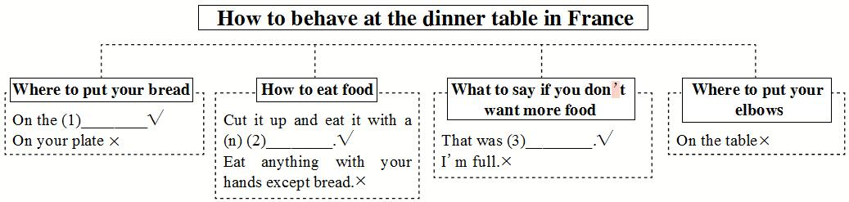

**Post reading**

Work on 2c.

1. Tell Ss that they have to learn to guess the meanings of the words they don’t know when they read the passage. Make sure Ss know what to do.

2. Ss read the passage again and replace the underlined words with the phrases in the box.

1. Making mistakes in French used to make Lin Yue nervous.

2. It was quite hard for her to feel good about speaking French.

3. The host family tried very hard to help Lin Yue.

4. Lin Yue has slowly learned how to be like her French friends.

|  |
| --- |
| went out of their way  be comfortable doing  gradually gotten used to being  (something) worry (someone) |

Work on 2d. Review the passage and make notes about French customs in the chart.

|  |  |
| --- | --- |
| Dos | Don’ts |
| You’re expected to put your bread on the table.  … | You are not supposed to put your bread on your plate.  … |

Don’ts：

You are not supposed to eat anything with your hands except bread.

You’re not supposed to say you are full.

You are not supposed to put your elbows on the table.

Dos:

You’re expected to cut up your fruit and eat it with a fork.

You’re expected to say “That was delicious” if you don’t want any more food.

**Ⅲ. Language points**

1. I was a bit nervous before I arrived here, but there was no reason to be.

reason to do sth. 做某事的理由

no reason to do sth. 没有理由做……

e.g. The police have reason to believe that he is guilty.

警方有理由认定他有罪。

You have no reason to be nervous.

你没有理由这么紧张。

2. They go out of their way to make me feel at home.

go out of one’s way 特地；格外努力

e.g. John went out of his way to make his girl friend happy.

约翰想方设法使他的女朋友高兴。

make sb. feel at home 使某人感到宾至如归

e.g. I’m doing everything I can to make them feel at home.

我在尽我一切所能使他们感到宾至如归。

3. You wouldn’t believe how quickly my French has improved because of that.

You wouldn’t believe …常用句式，“你无法想象……；你想都想不到……；你绝不会相信……”，表示所陈述的事情超出想象之外。与此类似的表达还有You would never believe…或You would hardly believe…。例如：

You wouldn’t believe that he found his long-lost sister in Taiwan!

你绝对想不到他在台湾找到了失散多年的姐姐！

You would never believe what quick progress he’s made ever since he attended your class.

你根本无法想象，自从他听了您的讲课后进步有多大。

4. My biggest challenge is learning how to behave at the dinner table.

learning how to behave at the table是现在分词短语，在此用作句子的表语。再如：

His main hobby is fishing. 他的主要爱好是钓鱼。

The most important thing is getting there in time. 最重要的事是及时到达那里。

behave

behave *vi.* 表现；行为，behave well / badly表现好/糟糕

e.g. The boy behaved very well last night.

★ behave as if / as though表现得好像……。如：

Bruce was a little boy, but he behaved as if / as though he was an adult.

★ behave + *adv.* + towards / to sb. 以……方式对待某人。如：

I think he behaved badly towards / to you that day.

★ behave oneself表现得体；有礼貌。如：

I hope Nicholas behaved himself at the party.

【语境应用】根据汉语意思完成英语句子，每空一词。

(1) 他们从不互相问候，表现得像陌生人。

They never greeted each other and ________ _______________ they were

strangers.

(2) 除非你表现得体，否则就不会得到任何礼物。

Unless you ______ _______, you won’t get any present.

5. … but I’m gradually getting used to it. get used to 习惯于

e.g. We get used to this way of speaking,.

我们习惯了这种说话方式。

辨析：

① be/get used to sth./doing sth. 习惯于…

e.g. He got used to living in the country.

他习惯住在乡下。

② used to do sth. 过去常常做某事（现在不做了）

e.g. He used to plant roses.

他过去常常种植玫瑰。

6. Another example is that you’re not supposed to eat anything with your hand except bread, not even fruit.

except *prep.* 除……之外，和but意义相似，但语气上要比but更加强烈。

1) Everyone is here except him.

2) We have classes except Saturday and Sunday.

**Ⅳ. Group work**

Work on 2e.

1. Group work.

Compare the table manners in France and China in your group. How are the same or different? Make a list.

e.g. In France, people put their bread on the table. But in China, we always put our food on a plate or in a bowl. We never put food on the table.

2. Share their ideas about the table manners in France and China.

**Ⅴ. Exercise**

Ⅰ. 根据句意及所给汉语提示，写出句中所缺单词。

1. Steve _________(举止) badly when he was young.

2. The restaurant is open every day _________(除……之外) Sunday.

3. The three _________(交换) students in my class are from America.

4. As a doctor, you should give the poor people _________(基础的) medical help.

5. Mrs. Trent was surprised to find the fridge _________(空的); the children had eaten everything!

6. Peter was at a restaurant with his teenage _________(孙女) when something unusual happened.

7. Carl sat with his two _________(肘) on the table.

8. Linda's health is improving _________(逐步地) day by day.

Ⅱ. 根据语境，从方框中选择恰当的短语填空，有的需要变换形式。

thanks for, go out of one’s way, make sb. feel at home, point at, be different from, cut up, get used to

1. It’s rude to __________________ one’s nose.

2. Driving on the left is strange at first but you will __________________ it.

3. My mother __________________ some meat to make dumplings for us.

4. —__________________ the tickets for next week’s game.

—My pleasure.

5. Ben knows I like reading. Last night he __________________ to send me many books.

6. Tom is a boy who is interested in science and his ideas __________________ those of his friends.

7. Mrs. White made some nice food for me and she tried her best to

____________________.

**Homework**

List the differences between France and China about table manners according to 2e.

**Section B 3 (3a-Self Check)**

一、**教学目标：**

1. 复习be supposed to do sth句型。掌握生词suggestion用法。

复习并学会用be supposed to, be expected to, It is important to, be impolite to等表达各国饮食起居，生活习惯和对时间的看法。

运用所学礼仪知识，句型，词汇进行写作。

2. 学习不同国家的餐桌礼仪，尊重不同的文化，养成良好的习惯。

二、**教学重难点**

写作方法和技巧。

**三、教学过程**

**Ⅰ. Warming up and revision**

1. Greeting.

2. 让学生展示作文：Table manners in different countries.

**Ⅱ. Lead-in**

1. Ask Ss to discuss the different table manners in different countries in a group.

|  |  |  |  |
| --- | --- | --- | --- |
| China | France | Brazil | … |
| meet for the first time |  |  |  |
| being on time |  |  |  |
| visiting friends |  |  |  |
| table manners |  |  |  |
| … |  |  |  |

2. Ss say something about Chinese customs and Chinese table manners and discuss:

How do a person behave properly in China?

1) What are table manners in France, Korea and other countries?

2) Discuss Chinese customs and table manners.

3) How do a person behave properly in China?

**III. Presentation**

Work on 3a.

1. Your pen pal is coming to China on an exchange program. He/She is asking you about Chinese customs and what he/she is supposed to do or not. Make notes in the chart.

|  |  |
| --- | --- |
| Table manners | It’s polite/impolite to… |
| House rules | You’re supposed/not supposed to… |
| Going out with people | You should… |

2. Fill in the chart and say the Chinese customs in English.

Chinese customs

Table manners

* It’s polite to ask older people to start eating first at the table.
* It’s not polite to pick up your bowl to eat.
* You’re supposed to use chopsticks to eat.
* It’s not polite to stick your chopsticks into your food.
* It’s impolite to point at anyone with your chopsticks.
* It’s impolite to knock your empty bowl with your chopsticks.
* …

House rules

◆ You’re supposed to greet the host family.

◆ You’re supposed to shake hands with people.

◆ You’re supposed to say “*nihao*” to people.

◆ You’re not supposed to bow, kiss or hug with people.

◆ …

Going out with people

* You should call first.
* You should make a going-out plan with friends.
* …

**Ⅳ. Writing**

Work on 3b.

1. Write a letter to your pen pal to give him/her advice and suggestions on how to behave properly in China.

2. 写作技巧点拨：

**1) 英语书信的写法：**

称呼Dear…， 左起顶格写。

正文换行，也要顶格写，是信的核心部分。因此要求正文层次分明、简单易懂。

祝福的话语，正文下换行，顶格写， 如: Best wishes! Take care! Happy New Year! Happy Birthday! 等。

结束语在正文下面的一、二行处，第一个词开头要大写，句末用逗号。结束语的写法Yours, Your loving…, Sincerely yours、Yours sincerely或Sincerely；在结尾语下面的署名必须亲自签名，也不加任何的标点符号。

**2) Useful expressions:**

**有关文化礼仪的写作常用句型**

You’re (not) supposed to….

You are expected to…

It’s polite/impolite to…

It’s important to…

You should….

**3. Give Ss an example:**

Dear Tony,

You must be excited about coming to China soon. Let me give you some suggestions and advice about Chinese customs. When you are eating at the table, it’s impolite to start eating first if there are older people at the table. You should let them start first. When you are eating with chopsticks, it is impolite to point at other people with your chopsticks. It is also impolite to stick your chopsticks into the bowl of rice and leave them there.

In our house, you’re supposed to take off your shoes before you enter the house or just inside the front door. In our culture, we don’t usually hug or kiss people.

When you go out with people, you should tell the hostess where you are going, who you are going with and when you will come back. In our culture, the hostess will worry a lot about the safety of her guests, so a polite guest will always let her know these things.

Have a safe trip, and I look forward to meeting you soon!

Best wishes

Xiao Wei

**V. Self Check**

**Work on Self Check 1:**

1. Let some Ss read the words in the box. Make sure all the Ss know the meaning of the words.

2. Let Ss read the sentences in Self Check 1. Then Ss try to fill in the blanks with the correct forms of the words in the box.

|  |
| --- |
| worth capital basic traffic empty mad knocking |

1) In many countries, it is impolite to show up at someone’s house for the first time with ______ hands. You should always bring a small gift.

2) Billy was very uncomfortable at a fine-dining restaurant last night because he didn’t know ______ table manners.

3) It is _______ spending the time to learn about the customs of a country before you go there. That way, you will know what you are supposed to do in different situations.

4) The ______ is always the worst in the ________ city. It is important to leave earlier if you are traveling by car.

5) Sandy went into her sister’s room without _________ on the door. That made her sister ______.

3. Let some Ss read their answers. Check the answers with the Ss.

Keys: empty, basic, worth, traffic, capital, knocking, mad

**Work on Self Check 2**

1. Tell Ss that they have to complete the statements below. They should write sentences about the customs with “ be (not) supposed to, be expected to, be polite/impolite to”.

2. Ss think and try to complete the statements by themselves.

In my culture, when you…,

you’re supposed to ____________

you’re not supposed to _________

you’re expected to _____________

it’s impolite to ________________

it’s important to ______________

3. Let some Ss read their sentences to the class.

4. Correct the mistakes they have.

**VI. Exercise:**

 Ⅰ. 根据括号内的要求完成下列各题，每空一词(含缩略形式)。

1. The party at Andy's house last night was very wonderful.  (对划线部分提问)

_________ _________ the party at Andy's house last night?

2. Tom gave me a good suggestion.  (用some将句子改为复数句)

Tom gave me _________ _________ _________.

3. The boy should get to the cinema at 7:00 this evening.  (改为同义句)

The boy _________ _________ _________ get to the cinema at 7:00 this evening.

4. My pen pal always feels good about speaking Chinese.  (改为同义句)

My pen pal _________ _________ _________ speaking Chinese.

5. 请当心碰头！ (完成译句)

_________ _________ _________, please!

6. 你绝不会相信他按时完成了所有的工作！ (完成译句)

_________ _________ _________ that he finished all the work on time!

Ⅱ. 阅读短文，从方框中选择恰当的词并用其适当形式填空，使短文完整、通顺。

|  |
| --- |
| custom, capital, greet, mad, season, gradually, except |

Dear Jason,

How are you in Australia? Now I'm in Beijing, the (1) _________ of China. At the moment it's winter in Australia. It's very cold. Different from Australia, it's summer here, the second (2) _________ of the year. It's very hot. As an exchange student, I'm learning Chinese in this beautiful city. In my class all the students are Chinese (3) _________ me. So in my class I felt nervous and worried at first. (4) _________, I got used to the life here. And now I know lots of (5) _________ here. For example, when I meet my friend on the street, I usually (6) _________ him like this, “Hey, where are you going?” In our country if someone asks this, people may get (7) _________ but in this country people won't. Of course, there are some other interesting things here. I'll tell you about them next time.

Yours,

Dale

**VII. Homework**

编写一份手抄报。把收集到的各国见面礼仪，餐桌礼仪，风俗习惯等信息制成一份手抄报。